

***School of Mechanical & Manufacturing Engineering (SMME),***

***National University of Science and Technology (NUST),***

***Sector H-12, Islamabad***

Program: BE-Aerospace Section: AE-01

Session: Fall 2023 Semester: 1st

Course Title: Fundamentals of Programming (CS-109)

Assignment#1

**Name: Muhammad Hayat**

**CMS: 453824**

**Question:1**

Write a C++ program, take two strings as input from user and check if both strings are equal or not. If they are equal make them unequal by rotating string. e.g., Hello is turned into olleH etc.

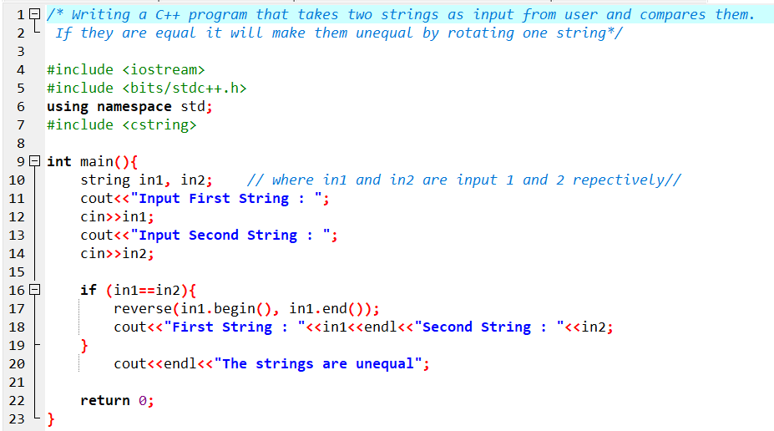

Figure Question1 Code



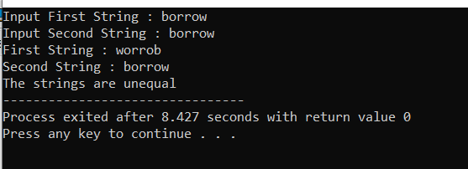

Figure Execution for Question:1

**Question:2**

Write a C++program for a string which may contain lowercase and uppercase

characters. The task is to remove all duplicate characters from the string and find

the resultant string.

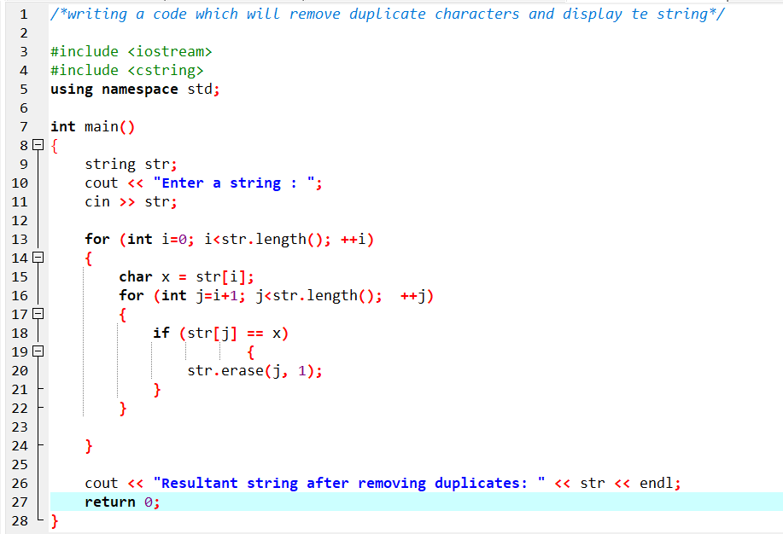

Figure Question 1 Code



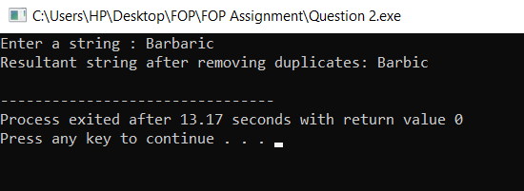

Figure Execution Question

**Question:3**

Suppose an integer array a[5] = {1,2,3,4,5}. Add more elements to it and display

them in C++.

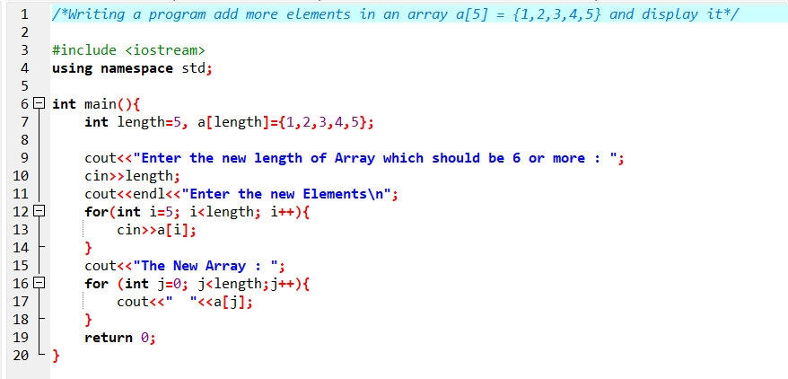

Figure Q3 code



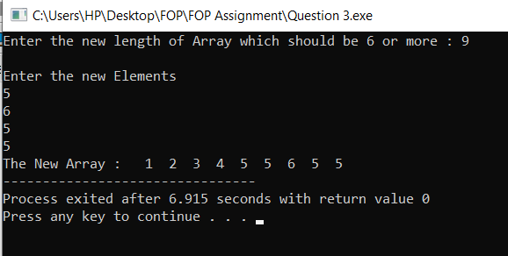

Figure Question 3 Execution

**Question:4**

Write a C++ program that uses a while loop to find the largest prime number less

than a given positive integer N. Your program should take the value of N as input

from the user and then find the largest prime number less than or equal to N. You

are not allowed to use any library or pre-existing functions to check for prime

numbers.

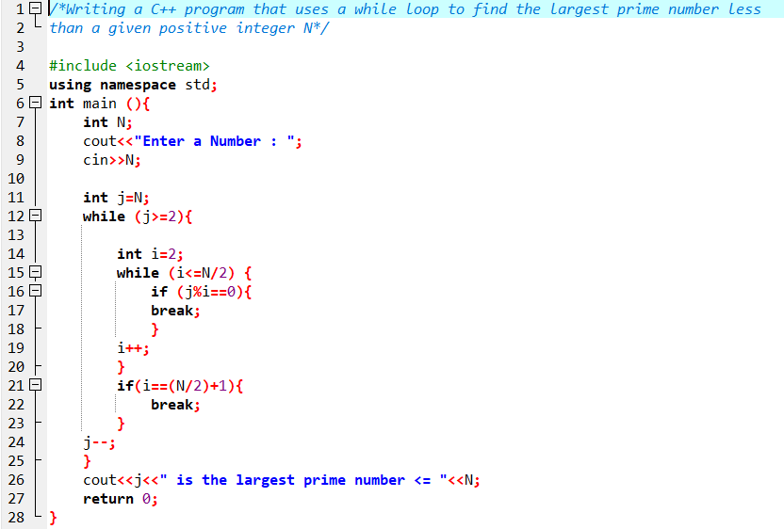

Figure Question 4 Code



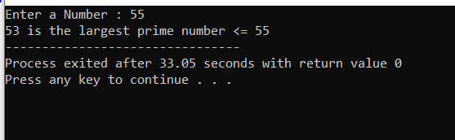

Figure Question 4 Execution

**Question:5**

Implement Bubble Sort on an array of 6 integers.

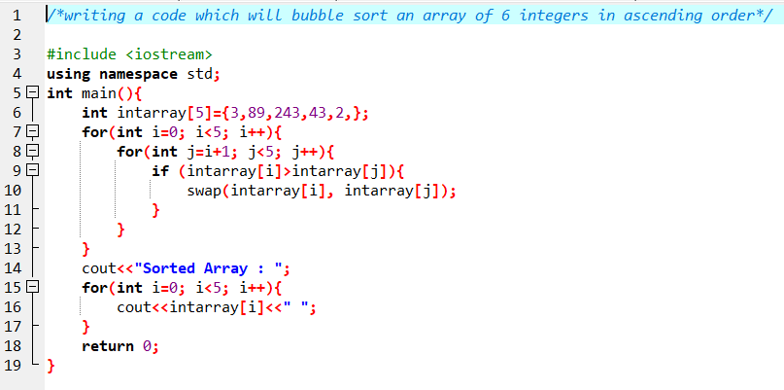

Figure Question 5 Code



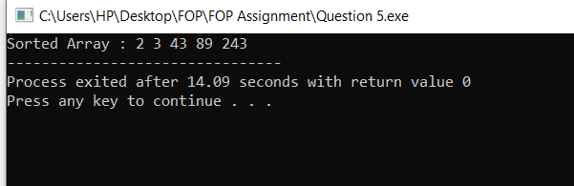

Figure Question 5 Execution

**Question:6**

Solve any Aerospace/Real Life Problem using C++ Programming.

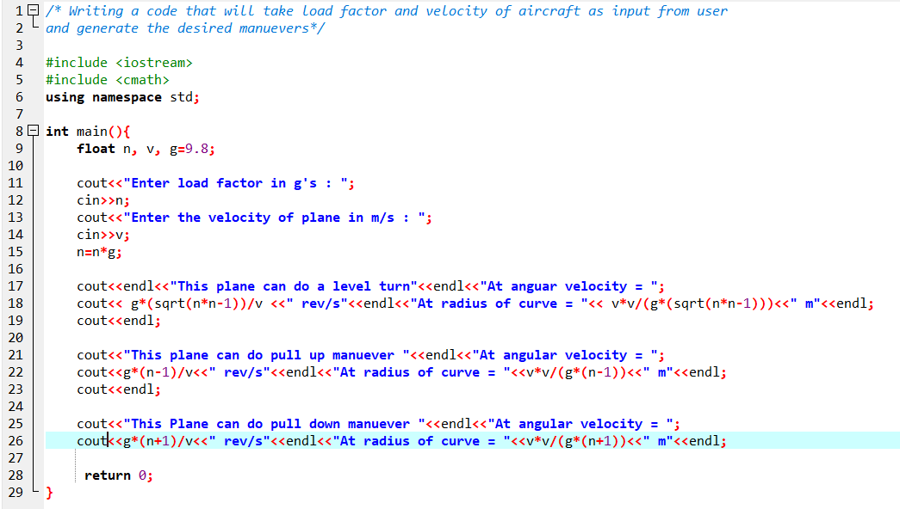

Figure Question 6 Code



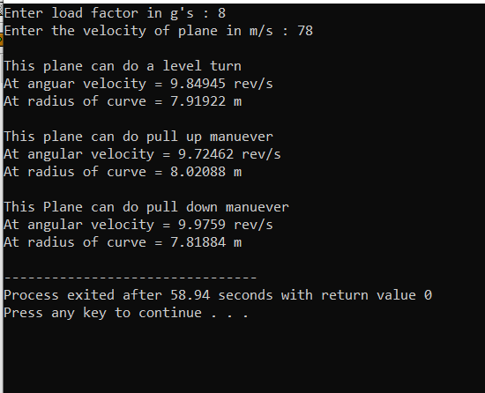

Figure Question 6 Execution